**ENGN4200 Individual Report:**

Development of a Portable Electroluminescence Measurement System for Photovoltaic Modules



By

Neil Bradbury (u5841150)

10 November 2023

ENGN4200 Semester 2 2023

Contents

Introduction 3

Background 4

Methodology 6

Recommendation 1: *Increase Image Capture from 8-bit to 12-bit Resolution.* 6

Recommendation 2: *Develop a More Secure and Portable Enclosure.* 6

Recommendation 3: *Implement Power Management to Optimise Power Consumption.* 6

Recommendation 4: *Create a PCB for the Electrical Circuit Subsystem.* 7

Recommendation 5: *Increase the current rating from 10 A to 20 A.* 7

Work to date 8

Activity Plan 9

Conclusion 10

References 10

# Introduction

This project continues the development work of a portable electroluminescence measurement system (PELMS) for Photovoltaic (PV) modules developed in Semester 1 2023 by the ENGN8170 student team, *Team Solar*.

Photovoltaic (PV) modules convert sunlight into electricity providing solar energy which is a renewable and clean source of energy. Electroluminescence (EL) imaging techniques are used to identify faults and problems within PV modules [1, p. 12]. The PELMS prototype developed by *Team Solar* worked by injecting a modulated current into a PV module to generate an EL image that could be used to identify the functional and non-functional areas of a PV module. The prototype could image one PV module at a time and produce EL images within 5 minutes [2, p. 1].

The *Team Solar* PELMS prototype served as a proof of concept that demonstrated the effectiveness of using EL image processing techniques for analysis of PV modules [2, p. 6]. The handover document of *Team Solar’s* PELMS prototype (see [3]) recommended the following areas of future work:

* increase image capture from 8-bit resolution to 12-bit resolution to improve image detail,
* develop a more portable and reliable enclosure, this will be an enclosure that houses components securely and prevents dust and water ingress,
* implement power management to optimize power consumption,
* create a Printed Circuit Board (PCB) for the current regulator circuitry currently seated on a prototyping board, and
* increase the current rating from 10 A to allow the device to scale to work with larger PV modules (see [3, pp. 14-15]).

These recommendations are itemised in Table 1 and the methodology, work to date and future activities for implementing these recommendations in this project is covered in this report.

|  |  |
| --- | --- |
| Recommendation No. | Recommendation |
| 1 | Increase Image Capture from 8-bit to 12-bit Resolution. |
| 2 | Develop a more Secure and Portable Enclosure. |
| 3 | Implement Power Management to Optimise Power Consumption. |
| 4 | Create a PCB for the Electrical Circuit Subsystem. |
| 5 | Increase the Current Rating from 10 A to 20 A. |

Table 1: ENGN4200 Semester 2 2023 PELMS Design Recommendations

# Background

PV modules operate by absorbing light and converting it into electricity in the form of an electrical DC current. Due to the reciprocity principle the opposite is also possible, where a current injected into a PV module will cause the module to emit light in the infrared (IR) range which can be captured by a digital camera. This process of emitting light from an electrical current is electroluminescence (EL) and process of capturing light images generated is EL imaging [1, p. 12].

The *Team Solar* PELMS prototype used an EL imaging process where the PELMS prototype would capture two images of the PV module:

* a visible light image of the PV module which is captured when no current is being injected into the PV module, and
* a noisy EL image of the PV module which is captured when a DC current is being injected into the PV module so that the image contains both visible light and IR light.

The visible light image is subtracted from the noisy EL image leaving only the EL image of the PV module. The EL image in this case may be used for qualitative analysis of the PV module where the dark areas in the image are indicative of the location of damaged PV cells in the PV module.



Figure : System Block Diagram

The system block diagram of the *Team Solar* PELMS prototype (see [2, p. 2]) is shown in Figure 1. The prototype had two subsystems: the **Electrical Circuit** subsystem which injects a current into the PV module and the **Camera Algorithm** subsystem which captures the images using an IR camera. Users can interface with the PELMS prototype via the Raspberry Pi display which gives the user a menu to adjust settings and start the measurement testing. The control of the system itself is performed by the Raspberry Pi which runs a program that sends a signal to the **Electrical Circuit** subsystem via the **RF Trigger** to the **RF Link** which signals the **Current Regulator** to adjust the current input from 0 to 10 A. An example of the current injection pattern is given in Figure 2 (see [2, p. 1]).



Figure : Current pattern and camera trigger timing.

As shown in Figure 2, the **Camera Algorithm** sends an RF signal in the form of a square wave that directs the **Current Regulator** to send a sequence 0 A and 10 A current injections into the PV module (as shown by the blue line in Figure 2). Images are captured at the camera trigger points (as shown by the orange diamond in Figure 2) and the differences between the pairs of images are used to generate the final EL image by taking the average from a given number of these image differences.

The result of an EL image capture using this process is given in Figure 3 (see [2, p. 5]). In this image the lighter areas are the functioning areas of the PV module and the darker areas indicate region in the PV module where no IR light is generated which indicates either there are no PV cells in this region of the PV module or that they are defective.



Figure : Electroluminescence result of a solar cell obtained with the system.

# Methodology

The methodology to implement each recommendation from Table 1 is given below and in cases where work for one recommendation affects another are discussed as required.

## Recommendation 1: *Increase Image Capture from 8-bit to 12-bit Resolution.*

The resolution of the images captured by the *Team Solar* PELMS prototype is determined by the python package used. The python program used to control the camera and capture the images is called *Camera.py* and uses the *Picamera* library package [4] which is a Python package that interfaces to the Raspberry Pi camera module that can handle 8-bit images. The python camera package *Picamera2* is based on the *Picamera* library [5] but can capture and handle 12-bit resolution camera images.

The methodology to achieve this recommendation will be to either modify or rewrite *Camera.py* so that it uses the *Picamera2* library to handle the 12-bit resolution images.

## Recommendation 2: *Develop a More Secure and Portable Enclosure.*

The *Team Solar* PELMS prototype used a 240 mm x 160 mm x 90 mm enclosure to house the **Electrical Circuit** subsystem and is shown in Figure 4. In this prototype the aim will be to use a smaller 170 mm x 120 mm x 55 mm enclosure. The main components housed in the **Electrical Circuit** enclosure are:

* **Electrical Circuit** subsystem prototyping board (on the right in Figure 4), and
* the **RF Link** board (shown on the left in Figure 4).

The methodology to achieve this recommendation will be to transfer the components from the **Electrical Circuit** subsystem from the 240 mm x 160 mm x 90 mm enclosure to the smaller 170 mm x 120 mm x 55 mm.

## Recommendation 3: *Implement Power Management to Optimise Power Consumption.*

The **Electrical Circuit** subsystem shown in Figure 4 contains the **RF Link** which uses a Linx PCB evaluation receiver board (PCB-EVAL-LR-RX) that is powered by 2 x 1.5 V AAA batteries. The **Power Source** in the **Electrical Circuit** subsystem (see Figure 1) could be used to power the **RF Link** by passing the voltage into the circuit of the **Current Regulator** where the internal circuitry could step the voltage down to 3 V to power the **RF Link**. The methodology to implement this recommendation would be to modify the circuitry so that the **Power Source** in the **Electrical Circuit** subsystem is used to power the **RF Link**.

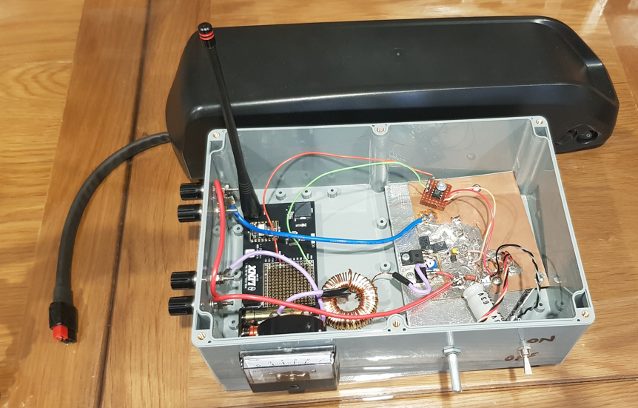

Figure : Team Solar PELMS Electrical Subsystem Enclosure

## Recommendation 4: *Create a PCB for the Electrical Circuit Subsystem.*

The **Current Regulator** function in the **Electrical Circuit** subsystem shown in Figure 1 is physically implemented by the prototyping board shown in Figure 4 (on the RHS of the enclosure). The next stage is to migrate the circuit from a prototyping board to a PCB which would improve the durability and simplify the physical fitting of the PCB in an enclosure. For this recommendation the PCB for the circuit could be created by drafting the circuit in a software design tool such as KiCad and the generated files could be sent away to a PCB manufacturer.

## Recommendation 5: *Increase the current rating from 10 A to 20 A.*

The original PELMS device implemented a current regulation circuit that had a 10 A current rating, and the recommendation was to increase this current to 20 A. To meet this recommendation, we need to consider two points:

* the current regulator function works by using a HV9910C integrated circuit to control the output current, this can be modified by changing the appropriate value of the current sensing resistor in the circuit, and
* ensuring the components for the circuit are all rated to handle 20 A which includes things such as lumped components, interfaces, and switches.

The modification to the current sensing resistor in the HV9910C integrated circuit will be relatively easy to change but the review and upgrading (when required) of all related components to meet the 20 A current may become complex depending on how many components need to be updated.

# Work to date

The work to date on the project has been in 3 areas:

* python software development for recommendation 1,
* PCB design for recommendations 3, 4, 5, and
* enclosure design for recommendation 2.

The first area of work to date has been software development work which has been to redevelop the python Gui that captures images. A *GitHub* repository has been created for this task and can be located at: <https://github.com/bradbn/pelms-2023-s2/wiki>. The two python programs that have been developed are:

* *pelms_menu_demo.py* (this is a python program developed to setup menu movement for the PELM GUI interface), and
* *Picamera2_Tk_raw_capture* (this is a python program the demonstrate 12-bit image capture).

This code will continue to be developed into a replacement GUI.

The second area of work to date has been PCB design. The *KiCad* software package has been used to develop a schematic of the PCB and to design an initial PCB, which is shown in Figure 5. I have shown the design to an Electronics Engineer, and I am currently working on the feedback, work is still needed to complete the design iteration before it can be be passed onto a PCB manufacturer.

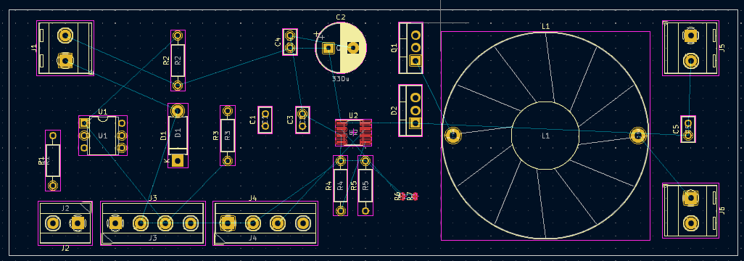

Figure : Initial prototype design for PELMS PCB.

The last area of work was on the device enclosure. The physical enclosure is available and is being used to see how the prototype PELMS PCB fits and how as a well other components fit together – at this stage everything is fitting but checks with PCB fit will need to be ongoing as at this stage we are likely to develop the PCB much further.

# Activity Plan

The activity plan for the next 6 months of the project is given in Table 2 below. The hardware-related tasks such as PCB design, development and manufacture are going to be given priority over the next 3 months i.e., because may need lead-up time to order components or maybe redesign parts. If that is completed, then I can start enclosure assembly in January/February next year. The software development will also be done but have lower priority as the software can be completed at later dates without affecting the project timelines.

One of the stretch goals for this project will be testing to evaluate the performance of the PELMS system this has been placed in February but maybe pushed later depending on how successful the Python GUI and PCB development are.

|  |  |
| --- | --- |
| Date | Activity |
| Nov 2023 | * Continue PCB Design and Development * Continue Python GUI Development * Catalogue any additional needed components |
| Dec 2023 | * Continue PCB Design and Development * Continue Python GUI Development * Catalogue any additional needed components |
| Jan 2024 | * Complete Python GUI Development * Complete PCB design and send design away for manufacturing. * Order any additional components as required |
| Feb 2024 | * Assembly of Prototype * Testing of Prototype * Organise (if possible) external product testing. * Troubleshoot any problems with protype |
| Mar 2024 | * Troubleshoot any problems with prototype. * Further Prototype Testing * Start Drafting Thesis Report |
| Apr 2024 | * Start Drafting Thesis Presentation * Start Drafting Documentation i.e., User documents, Handover documents and Test Results |
| May 2024 | * Deliver Thesis Presentation * Submit Thesis |

Table 2: Activity Timeline

# Conclusion

The current state of the project can be summarized as follows:

* In this project we are looking to complete the 5 recommendations in Table 1 that will continue development work for a Portable Electroluminescence Measurement System.
* The original protype worked by injecting a current into PV modules to generate an EL image. This project will use the same algorithm but aims to make it more effective by implementing the 5 recommendations.
* A methodology for each recommendation has been established.
* Work has commenced on all recommendations – the python development the most successful at this stage and the PCB design has commenced but we’re still iterating to develop a PCB with a working functional design that can be manufactured.
* A simple activity plan for the project has been given in Table 2 where we are prioritizing the hardware-related activities as it is more difficult to accelerate work on these activities in later stages i.e., if you are dealing with component orders or manufacturers.

# References

|  |  |
| --- | --- |
| [1] | U. Jahn and M. Herz, “Report IEA-PVPS T13-10:2018 Review on Infrared and Electroluminescence Imaging for PV Field Applications,” International Energy Agency Photovoltaic Power Systems Program, 2018. |
| [2] | A. Leong, B. Radhakrishnan, B. Ashok, L. Zhang, Y. Lu and Z. Zhou, “Development of a Portable Electroluminescence Measurement System for Photovoltaic Modules,” Australian National University, Canberra, 2023. |
| [3] | A. Leong, B. Radhakrishnan, B. Ashok, L. Zhang, Y. Lu and Z. Zhou, *Development of a Portable Electroluminescence Measure System for Photovoltaic Modules - Handover Document,* Canberra: Australian National University, 2023. |
| [4] | “Picamera,” [Online]. Available: https://picamera.readthedocs.io/en/release-1.13/. [Accessed 7 November 2023]. |
| [5] | Raspberry Pi & Raspberry Pi Foundation, “Picamera2,” [Online]. Available: https://pypi.org/project/picamera2/. [Accessed 7 November 2023]. |